


Young Activists for Peace and Climate Justice
Darmstadt Bessunger Forst 12.06. - 19.06.2023
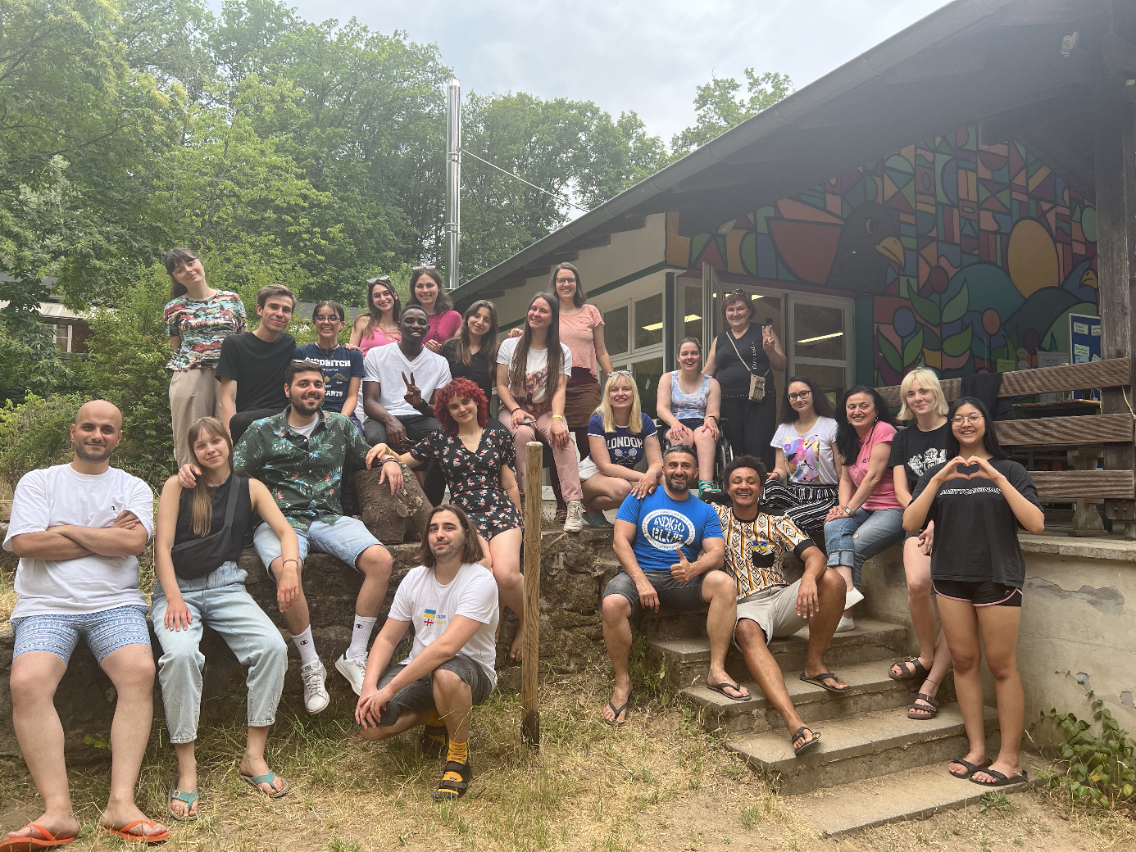
Daily Reports

ICJA Freiwilligenaustausch weltweit e.V. / Löwengasse 27 C / 60385 Frankfurt
Tel.: +49 (0)69 98191957 / youthexchange@icja.de / www.icja.de

Background of the Initiative
Since 2015, ICJA offers trainings and youth exchanges in the frame of a concept we call “Young Activists for Peace”. Until now over 400 participants came from different corners of the European Union, Eastern Europe and Caucasus, as well as the Mediterranean Region
The “Young Activists for Peace” projects offers a wide range of activities, topics and pedagogical concepts in the field of peace education, trainings for democracy, empowerment of youngsters with fewer opportunities etc. We do this, because we believe in the impact of this work on the young participants who will contribute democratic and peaceful societies in the long term.
Global warming is a fundamental threat to all people on earth, but in different ways: The lifestyle of the rich is the main cause of the greenhouse effect; people in the global south suffer the most from the consequences, like drought, heat waves and floods. Especially poor and young people in the global North and South are bearing the consequences of a climate crisis they did not cause.
The focus of this training was the worldwide fight for climate justice. Together we looked for positive role models and helpful competences to achieve a more peaceful and sustainable future for all of us.

Goals of the Training
The training was held for young activists who wanted to get knowledge and skills and actively work for climate justice and peace. About 25 youth and young adults from Europe and neighbouring countries were invited to the training. The goals were:
- to get to know people, initiatives and their activities for climate justice;
- to gain an overview of the global problems caused by global warming and environmental pollution;
- to share experience and practice with other international participants and their youth organisation and jointly develop new methods and approaches in the field of sustainability and the UN sustainability goals;
- to receive official recognition of participation in this learning experience afterwards;
The training consisted of the following modules:
- Workshops on understanding global warming e.g. "climatefresk”
- Workshops on just and sustainable nutrition e.g. "Food Justice".
- Workshops with examples from Global Learning;
- Visit to the Rainforest Centre "Centre for Global Sustainability"
- Workshops on creative events and campaigns on climate justice
- Learning from best practice: Excursions to initiatives in Darmstadt and Frankfurt that work for climate justice, e.g. Fridays for future, students for future.

Activities in Details
Day 1 – 12.06
- Arrival and housing
- Getting to know each other
- The 20-Minute Challenge
- Free-time activity

Day 2 – 13.06

- Rainforest center visit
- Climate Fresk with Koala Kollektiv in small groups
- Reflecting on how climate change impacts our emotions
- Reflection of the day with our facilitators
- Hike to the lake
- Free time with games and writing report

Day 3 – 14.06
- Small warm-up activity
- Team building activities
- Acknowledgement and reflections
- Participants’ map
- Climate justice activism discussion
- Energizer
- Making our Creatures
- Peer to Peer (presentations of organizations)
Day 4 – 15.06
- Yoga
- Introduction about food justice
- Discovering our target groups
- Association game with cards
- “Wall of shit”
- Lunch
- “Wall of vision”
- Watching videos about planetary health diet
- Cooking together healthy food- based on planetary diet princips
- Trip to Darmstadt

Day 5 – 16.06

- Energizer – dance
- Simulation game
- Reflection
- Dream journey and feedback
- Board game evening

Day 6 – 17.06

- Energizer
- Newspaper Activity
- Frankfurt Trip
- Workshop with Matias at Park
- Garden
- Time in the City

Day 7 – 18.06

- Energizer – dance
- Evaluation
- Self-evaluation
- Feedback
- Wishes for other participants
- Farewell party

Day 8 – 19.06
- Farewell & Departure

Daily Reports

DAY 1 - Monday, June 12
Arrival and housing

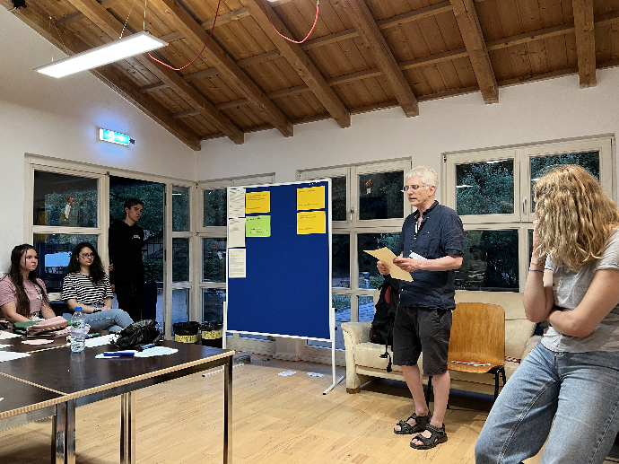
On the arrival day, participants started coming in the afternoon, but due to delays and other issues some didn’t manage to arrive until late evening. Still, the atmosphere was very positive from the start, and as the group was slowly coming together, everyone was happy to see each new member joining in. We were divided in two buildings, with everyone having more than enough living space for the upcoming week, so the housing process went fairly smoothly. We also got to know the two main facilitators, Cornelia and Lars, as well as the main organizer, Nikolaus and the cook for the week, Georg.

The 20-Minute Challenge
The facilitators offered us a 20-minute challenge, where we were divided in 4 groups and were given a list of tasks to complete. The tasks varied from general team building exercises, to more topical tasks centered around the issue of Climate Change and Climate Justice. Some of the exercises were also designed to help us get acquainted with the activities of the upcoming week. The overall number of tasks was 16, and they varied from coming up with the name for the team, to making a short song and dance number to perform in front of the group later. After finishing the tasks, we were invited to the first dinner, made by Georg, and after the dinner break we presented the completed tasks to the audience. The challenge helped us to get to know each other better, build trust and share our creative talents among each other, and all of this in a fairly short amount of time.

Conclusion
To summarize, through both the great effort of facilitators but also establishing the first good impression between each participant, an environment of openness and trust has been created. Through the engaging exercises we learned about each other, mainly the fact that the participants come from about 15 countries which offered us an opportunity for endless conversations about our cultures, their similarities and traditions. Overall the crucial environment, providing a feeling of safety and acceptance, could be felt by every person from almost the first moment of arrival which has setup a perfect atmosphere for learning and getting the most out of the project.

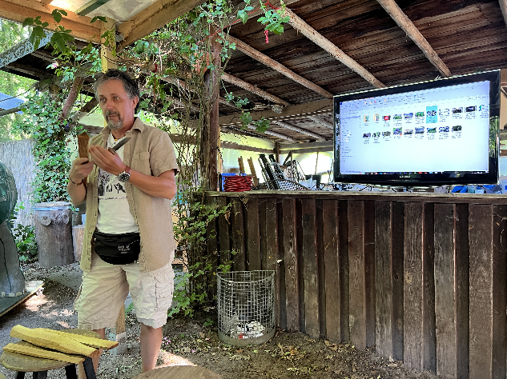
DAY 2 - Tuesday, June 13
Hiking in the forest
After Klaus Berger has told us some facts about rain forest and the difference to usual forests, he invited us to a tour to the forest nearby. He always tried to make the workshop interactive so he asked us to measure the circumfere of the tallest tree in the forest. It was 3.5m. Then we compared it to the broadest tree that Mr. Berger has measured in the Amazon with a width of 21 meters. The tallest tree in Darmstadt that was logged was 135 meters tall and the talles tree alive measures a height of 115 meters. He also showed us how to measure the hight of a tree. It works with mathematics and with calculating the angle between a stick that has the same size as the person measuring the height of the tree.
After that, Mr. Berger showed us some resin, leaves and peaces of the rind to smell.
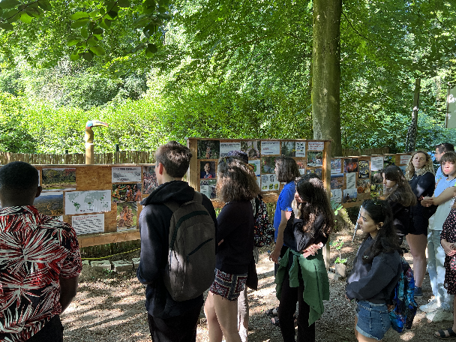
On the way we learned why leaves are green: It is because of the different spectrum from the sun light. The leaves absorb all colours from the spectrum besides the green spectrum that it reflects. Therefore the leaves appear in a green colour. We also had a look at the formula of photosynthesis.
On more thing we learned was that Douglas have bitter needles, so next to the trunk there are no other plants growing.
Climate Fresk with Koala Kollektiv in small groups
We were split up in 4 groups out of 5-6 people and divided on different tables.
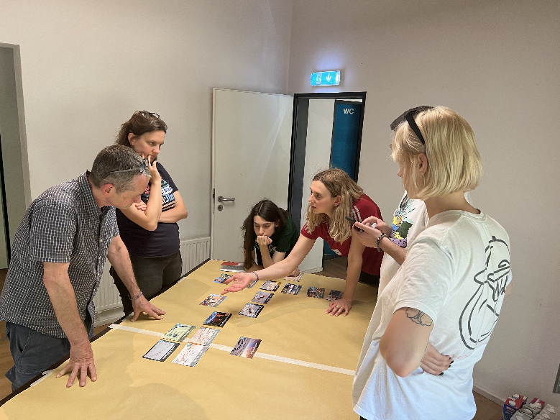
In the first round Bernd and Holger gave us five cards with different words on it. Our task was to put the cards in a causal change. Starting from Human Activities and then adding in a line all the topics that are impacted by the last card. From time to time they approached us to chek how we are doing and helped us a bit if we got stuck. After we set the cards in the order, we got the next five cards to arrange in the logical result chain. In the end all the groups had around 20 cards and we figured out it always became more and more complex and that one cause can have many impacts. We learned that permafrost is at upmost importance for the climate change because it stores a lot of methan that evaporates when the permafrost starts to melt.

CONCLUSION
The day entailed many interactive activities in which the participants enhanced their knowledge on climate justice and rainforest preservation and conservation. The participants had the opportunity to get to know each other and exchange perspectives about the importance of climate justice and significance of raising awareness on the climate crisis.

OUTCOMES AND APPLICATION
We learnt about the various ways of climate activism and some of the Non Governmnetal Organisations that we could join and the roles we can play in climate activism. The participants also gained practical and firsthand experience on measuring the heights of trees.

DAY 3 - Wednesday, June 14
BREAKFAST TIME
In the breakfast we had variety of food, including but not limited to eggs, different types of cheeses and butters, homemade and fabric breads, different types of cereals with varieties of milks, coffee, and many types of teas.
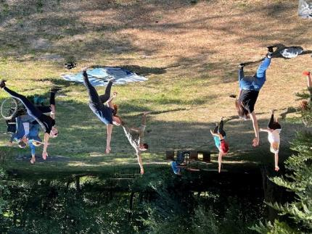
The breakfast time was very active, and many people were discussing with each other not only the topic of the seminar, but also sharing some interesting information about their home countries and cultures.
WARM-UP ACTIVITY
The warm-up activity was yoga, and although it was voluntarily, but almost 9 participants took part of it and made some stretching and yoga. Others at the same time were just enjoying the sun and the beauty of the forest and the sounds of the birds. Yoga instructors was Elise from France and Asya from Turkey.
During the yoga training participants learn how to do proper sun salutation, meditation, and stretching. One of the participants later shared her impressions, saying that morning yoga gives her refreshment and new energy, which is enough for the whole day. Almost all participants expressed their willingness to do yoga again every morning for the entire period of the training.
TEAM BUILDING ACTIVITIES
The team building activities started with acknowledgement and reflections. All participants have spoken about how they will and what they would like to improve. Exclusively all participants expressed their special thanks to Georg for preparing the wonderful food and expressed their satisfaction with today's breakfast. Many of them were thankful for organizing a good Yoga activity and for playing some western culture songs before the training session.

For the FIRST Warm-up exercise Cornelia requested us to put us on the map to show where we live now.
The group divided the area according to the north, south, east, west sections, chose the Black Sea as an orientation and placed itself according to the respective areas, then, as an introduction, presented themselves and their countries.
Then, Cornelia asked the second question: what do you consider as your home? And surprisingly, it was very interesting how much diversity this group has. It spread out from Sweden in the north to Kenya in the south and from Thailand in the East to the USA in the West, From Costa Rica to Estonia.
As a second Group teambuilding exercise, Lars- requested us to talk about the reason of participation of the training and asked to answer to 4 questions. According to the questions participants allocated in 4 different areas։
- I came here because of climate Justice,
- I came here because of youth work exchange,
- I came here because of adventure and travel,
- I came here because of Development myself.
Participants presented both their expectations from this training, and presented the purpose for which they came to participate in the training: climate justice, youth exchange program, adventure or development if themselves.
Then Lars requested to divide according to the following classification (Activism VS Conservativism):
- Yes, I am Activist,
- No, I am not an activist.
During the exercise we have discussed about Activism, and made a definition of what is Activist, and who considers himself as an activist.
Last. But not least, as a teambuilding exercise, we have discussed about Sustainability and do we consider our life as a sustainable or not.
After this series of discussions, we played an energizer (hu-ha-hi).
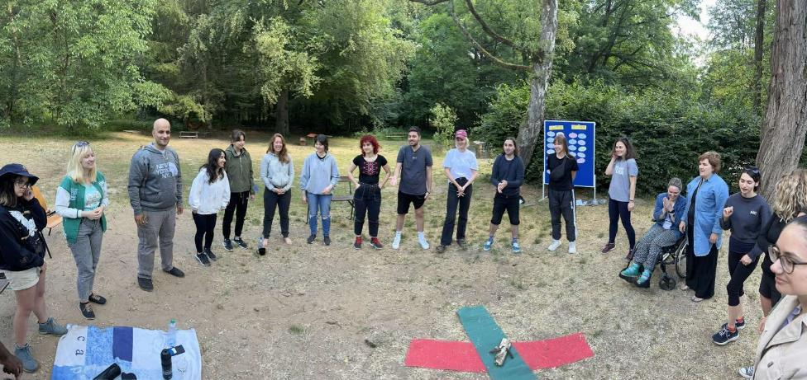
After the energizer we discussed about social rules, which the participants wrote in the board at the first day of the training. The meaning of the social rules was to find out those, that are important to me this week for a good team experience. Particularly, we have discussed about the following rules:
- Conflicts are normal, we should share opinion, find solutions for problem, love each other,
- Be/Start on time,
- Listen to each other,
- Be nice with nature,
- Do not leave anyone out,
- Speak in a common language so everybody who is present can understand,
- Keep smiling, say hi every morning,
- Respect each one and do not lough when he/she speaks,
- No hate speech, no homophobia, no judgement, no stress,
- No discrimination,
- To hear everyone,
- To be yourself.
Participants agreed with all the rules and decided to keep them during the training period.

Making our Creature
Cornelia asked participants to divide into 5 groups to have group exercise and within 10 minutes build a Creature and have a story about it. Within 10 minutes, the groups prepared small presentations, which are shown below․
People as an equal nation
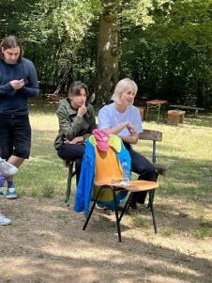
Our creature represents people as an equal nation. Chair is a place that everyone can sit and connect with each other’s. On top we put water, telephone (which symbolizes technology), charger (symbolize electricity) and plastic bag that symbolizes sustainable life. This thing should be available to everyone since we all deserve it. We believe that ‘chairman’ should be direct connection between people no matter the race, economy situation, power and other boundaries that sometimes stand between us. One of the groups have chosen a creature called poncik which limits the human’s resources when there is overconsumption. With the help of poncik humanity will be more conscious and take actions of their resource consumption.
Allay
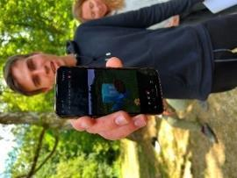
Allay always loved helping others. His friend Steve always told him what to bring and he went to get it. But one day he lost his way and couldn’t find his friend again. After being very lonely Allay decided to leave the world of Minecraft. He came through a portal into our world where he found he found his purpose in gathering garbage and giving it to people that could find usage for it.

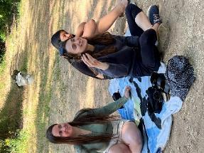
Peace branch
You see a piece of branch on my hand. But it is a branch lost its leaves. And as you know olive oil represents peace. We wanted to mention the world need peace today. But it ‘s losing it day by day like this branch. It should not lose peace in order not to be dead like this branch.
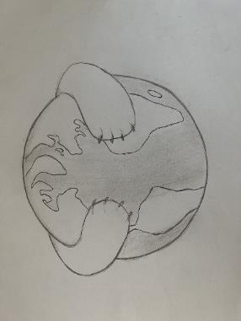
Hugging Earth
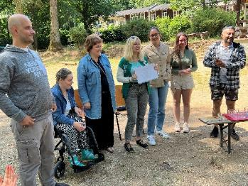
Water is one of the most important factors of the world. Life originated in water. The first protein was formed in water, from which the flora and fauna were created. Obviously, we cannot exist without water. We are all people. And just as the earth needs water, so people need love and warmth, which we can receive by hugging each other. And our creature is a Hugging Earth.
Wonder Bobby
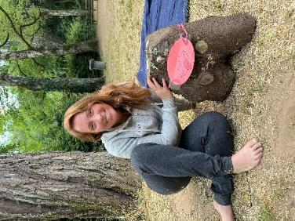
I would like to present to you our new friend Wonder Bobby. Please be quiet and don’t make fast movements. He is still a bit shy. Today was Wonder Bobbys first contact with humans. We found him hiding into the forest. We were really surprised because we have never seen such a creature before. We approached him carefully and asked if he wanted to be our friend. He said YES and he told us that his whole life he was just waiting us humans to approach him and ask if he wants to be our friend. He said he wants to help us with our problems because if we go on destroying the planet, he and the other Wonder Bobbys will also do not have future. So he asked us how he could help us and the first that came into our mind is the problem with the tons of waste that we humans produce but do not really handle the remaining waste. Wonder Bobby told us something that surprised us a lot and that we would have never thought to be possible. He can make real wonders. Therefore his name is also Wonder Bobby. He revealed to us that he can eat rubbish and through his digestion transform it into fresh air. We were so happy because this will already solve many human problems. After a while we had another thing in mind where we could definitely need help: there are many wars on the earth between different countries, region, religions, cultures … etc. We figured out that what actually could end all wars is: LOVE. So Wonder Bobby answered: No problem. I bring love to the world. Then you all can live in peace and there is no need for conflicts and war anymore because we all like each other and can happily live together on this planet. Humans and all other creatures side by side.

LUNCH TIME
For lunch, George served us three types of lasagna:
- With tomato and lentils,
- with cheese and oats,
- and the vegan kind.
The participants once again expressed their satisfaction with the meals prepared by George․

WARM-UP ACTIVITY AFTER LUNCH (Evolution Game)

With the support of one of the participants Jimena (From Costa Rica, but currently leave in Austria), Participants started to play the Evolution game.

Peer to Peer (presentations of organizations)
During this session, participants presented their organizations and made small presentations, as well as provided some traditional food and candies.
Nona Khizanishvili presented her organization: “Civil Forum” and Irakli Asanishvili presented one of the projects. Nona also presented some specific cultural traditions and food, such us chrchkhela, tghlapi, cheese and chocolates.
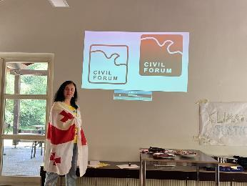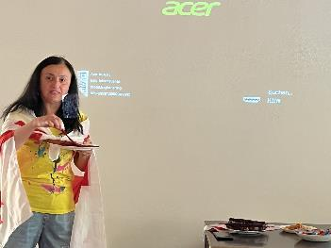

Jana Raus Presented her organization “Climate Aliance”
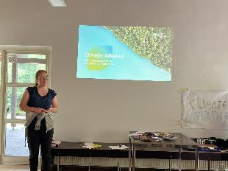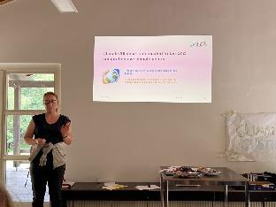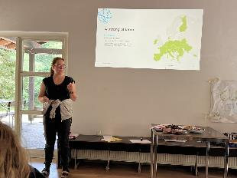
Konstantinos Kalogirou presented about his organization called Elix.
Elise Rousseou presented her organization: The French Young Europeans = national section of the Young Europeans Federalists Movement
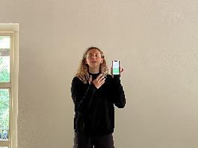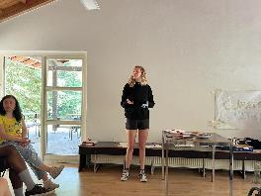
Silvia Miadokova presented her organization: Mladiinfo Slovensko
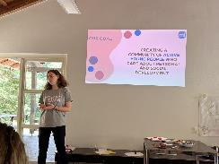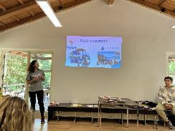
Narek Botsinyan, presented his organization “Progress” Youth NGO, as well as some traditional food from Armenia:
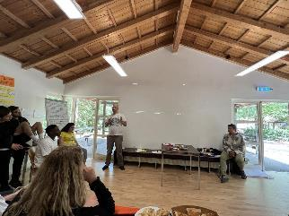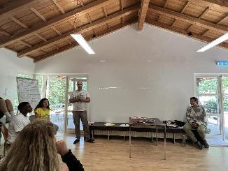

Ayse Asya Arslanturk presented their organization - PIYA
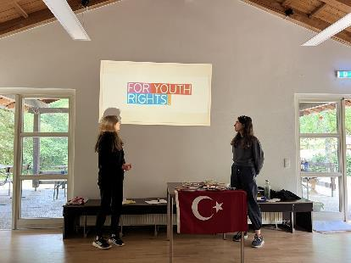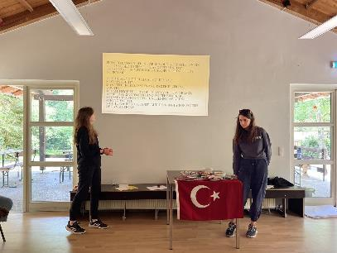
Anna and Lianna Derkach presented their organization “Eco Shall” and shoed movie about their activities:
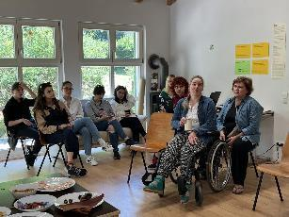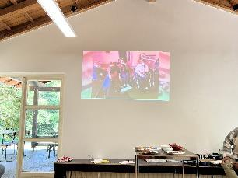
Sofiia Boichenko, Regina Stets, Elizaveta Scherbina talked about ecocide in Ukraine caused by Russian invasion.
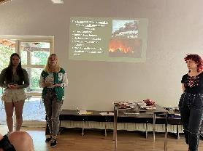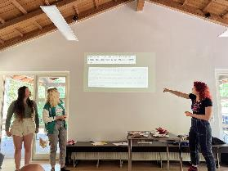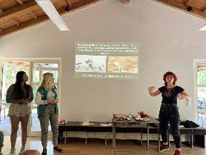
DINNER TIME
We had Mexican burritos for dinner․ We also had some Armenian wine and made a toast for the peace and for Climate Justice.

DAY 4 - Thursday, June 15
(Facilitator Dina —-)
“Yes or No” ACTIVITY
The day began with a rejuvenating yoga session that set a positive and energetic tone for the activities ahead. We engaged in various yoga poses, breathing exercises, and mindfulness practices, promoting physical and mental well-being. The collective practice of yoga helped us connect with ourselves and establish a harmonious atmosphere within the group.

Following the yoga session, we delved into the concept of food justice, understanding that it encompasses more than just access to food. Through an insightful and interactive session, we explored the importance of equitable access to healthy and sustainable food for all individuals, regardless of their socio-economic backgrounds. We discussed the impact of systemic inequalities, food deserts, and the need for community-based initiatives to address these issues.

To stimulate meaningful discussions, we initiated a thought-provoking "Yes or No" activity. Participants were presented with thought-provoking questions related to food justice, such as:
- “If you eat unhealthy food and you get sick, is it your fault?”
- “Should healthy/sustainable food be an obligatory subject in school?”
These questions sparked lively debates, allowing us to explore diverse perspectives and challenge our own assumptions.
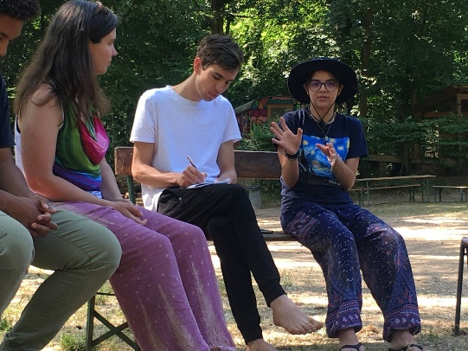
Discovering our target groups
Recognizing the diversity within our group, we formed small teams to identify and analyze our respective target groups. Through productive discussions, we discovered that our impact could extend to various demographics, including young people, individuals with disabilities, older adults, low-income communities, and marginalized populations. We explored the unique challenges faced by each group and brainstormed strategies to address their specific needs. Sharing these perspectives enriched our understanding and broadened our scope of influence.
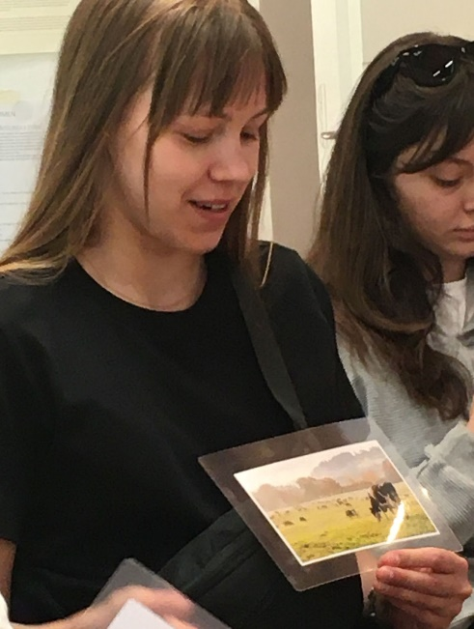
Association game with cards
Following a brief break, we engaged in a creative association game designed to stimulate our minds and encourage lateral thinking. Each participant selected a card from a deck and shared their associations with the group, explaining the reasoning behind their choices. The associations made were incredibly diverse, ranging from thought-provoking concepts to emotional connections. For example, a card depicting a poultry farming facility with poor conditions prompted discussions on animal cruelty, ethical concerns within the food industry, and the need for more sustainable farming practices. This activity fostered creative expression, critical thinking, and deepened our understanding of the multifaceted aspects of our work.

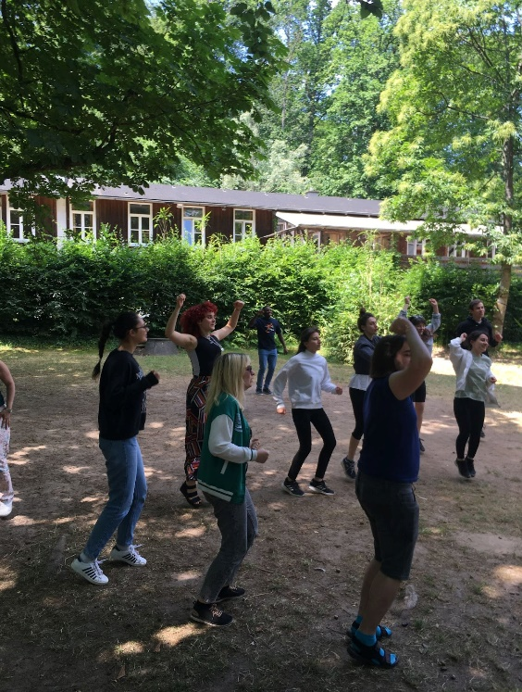
Energizer (Mediation)
As the day progressed, we took a moment to reenergize ourselves through a series of energizing activities. We are engaged in guided meditation, practicing mindfulness and deep relaxation. The soothing meditation session allowed us to quiet our minds, reduce stress, and enhance focus. Additionally, we participated in energizing exercises like jumping jacks, stretching, and joyful screams, invigorating our bodies and renewing our energy. This revitalizing break allowed us to reset our focus and approach the upcoming discussions with renewed vigor and clarity.

“Wall of shit”
This exercise was all about things that scares us and we find disturbing in the food industry. We divided our answers into 4 groups: social injustice, profit/financial, lack of education, environmental issues.
Unfortunately we found a lot of things to put on the wall for example:
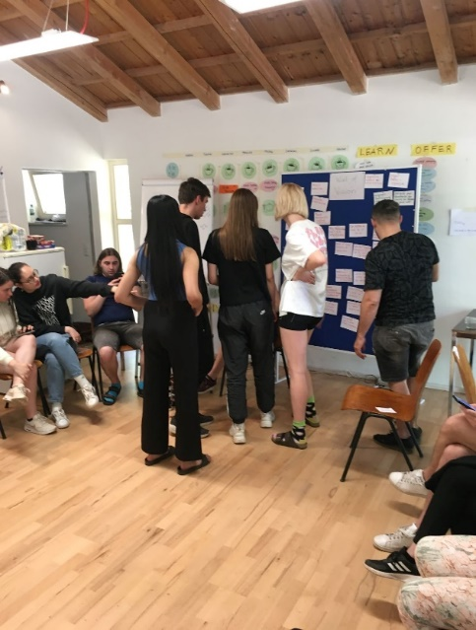
- Lack of support for local production/distribution
- A lot of food being thrown away
“Wall of vision”
Despites all of those negative things that we wrote on the wall we were still able to create a better vision. We thought about the solutions for every issue and we transformed “wall of shit” into “wall of vision”. It helped us to understand problems and find useful solutions.
Watching videos about planetary health diet
We watched 2 videos: first was an introduction to the topic and the second one was Johan Rockstrom press conference “Food in the Anthropocene”. Videos on the Planetary Health Diet further deepened our understanding of the link between food choices and the health of the planet. We watched an introductory video emphasizing the importance of the Planetary Health Diet for global sustainability and human well-being. Additionally, a thought-provoking press conference by Johan Rockstrom provided valuable insights into the role of food in the Anthropocene era, inspiring us to take proactive steps towards adopting a more environmentally friendly and health-conscious dietary approach.
Cooking together healthy food- based on planetary diet princips
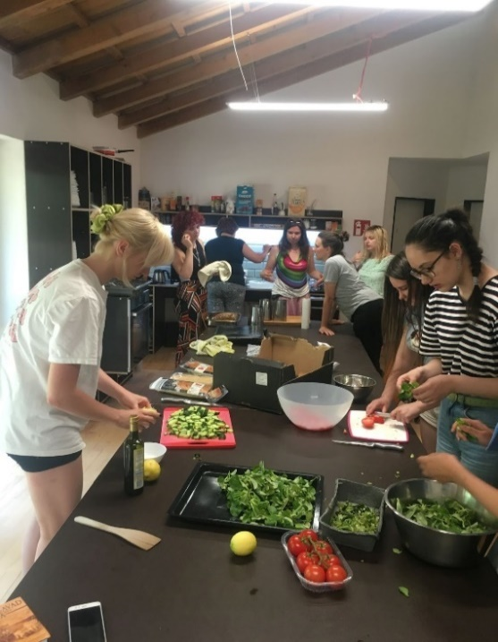
We cooked all 3 dishes for dinner. All of that was based on the planetary health diet as we followed the principals. Putting theory into practice, we engaged in a hands-on cooking session, preparing healthy and delicious meals aligned with the principles of the Planetary Health Diet. Collaboratively cooking together allowed us to share recipes, exchange culinary tips, and experience the flavors and benefits of a sustainable dietary approach, fostering teamwork and camaraderie.
Trip to Darmstadt
After savoring the fruits of our culinary efforts during dinner, we embarked on a memorable trip to explore the vibrant city of Darmstadt. The guided tour of the city center offered a chance to marvel at famous landmarks, immerse ourselves in the cultural ambiance, and further bond as a group. This excursion provided an ideal conclusion to a day filled with enlightenment, collaboration, and inspiration.

DAY 5 - Friday, June 16
Simulation Game
The primary objective of the simulation game was to draft a Framework Convention for a
planetary healthy diet. Participants were divided into different groups, each assigned various
roles. These groups included two state governments, Kaleido and Northland, as well as big
corporations representing lobbyists and other economic parties. Additionally, there were
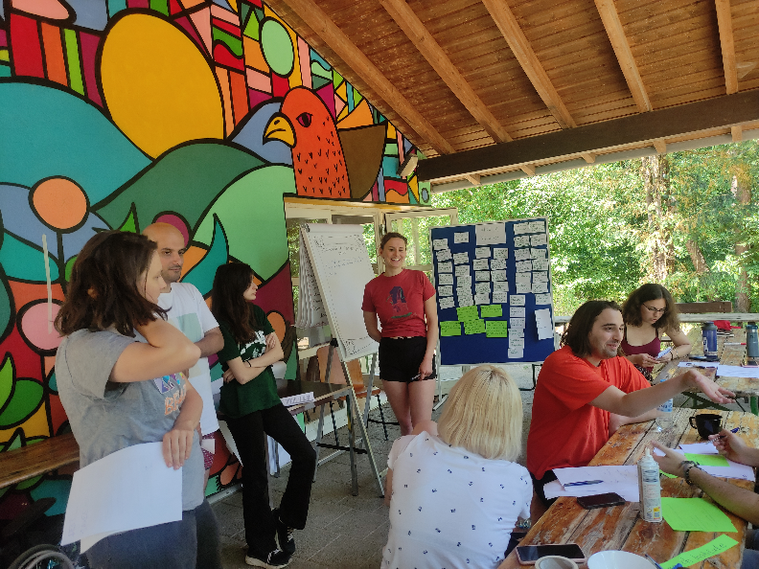
research institutions and civil society representatives. Each party consisted of two to three participants who were given specific duties, goals, and comprehensive information about their respective organizations. During the initial phase of the game, participants examined their materials and formulated strategies. Subsequently, they engaged in negotiations with one another through bilateral meetings. In the second phase, the players were split into two groups: political and economic. The political and civil society representatives were tasked with drafting the Framework Convention through negotiations, while the companies were permitted to lobby and send notes to the participating parties. Finally, after the Convention was drafted, a press conference was held where all the participants came together to express their viewpoints and
whether or not their goals had been achieved.
Reflection
Upon completion of the simulation game, participants discovered that the two imaginary
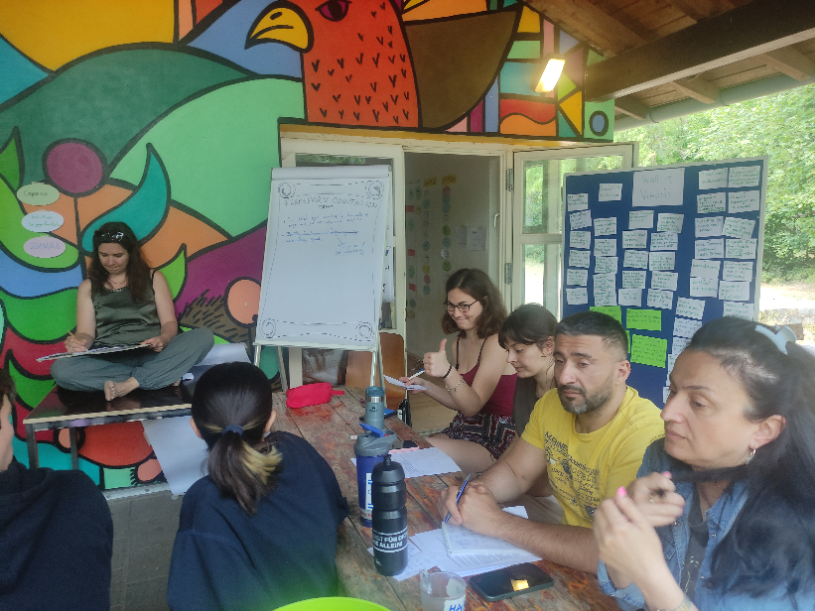
countries, Kaleido and Northland, were based on real states, with Kaleido representing Mexico and Northland representing Germany. During the reflection session, participants shared their experiences regarding the negotiation process and their feelings in their respective roles. For instance, Frame and Jana expressed their dissatisfaction, as they felt their roles were minor and lacked the necessary authority and power to make a significant impact during the game. Silvia, who represented the Kaleido government, mentioned feeling pressured into making decisions that aligned with the goals of economic parties and civil society organizations. Dominik and Jimena, who represented the economic corporation Tasty Food, approached their roles with a high level of dedication. Despite their personal beliefs, they prioritized representing the interests of the big companies, which are integral to the current economic system. By renaming their corporation to Healthy But Tasty Food, participants experienced firsthand the manipulative tactics corporations employ to maximize profits.
Dream Journey and Feedback
Following the reflection session, the entire group ventured outside and formed a circle on the ground. Dinah, the trainer from Berlin, led guided meditations aimed at deepening participants' reflections on their thoughts and emotions during the simulation game. After the dream journey, participants were asked to provide feedback regarding their likes and dislikes of the activities conducted over the course of the two days. The feedback collected will aid trainer Dinah in refining her methods and the structure of future training sessions.
Conclusion
In conclusion, the simulation game provided participants with valuable insights into negotiation dynamics, stakeholder influence, and the challenges of balancing personal beliefs with organizational interests. They learned about strategic planning, effective communication, and the pressures faced by policymakers. The experience also highlighted the manipulation tactics used by corporations for profit maximization. Through reflection and a guided dream journey, participants further processed their experiences, enhancing self-awareness and empathy. The feedback collected will improve future training methods. Overall, the simulation game fostered collaboration, critical thinking, and a deeper understanding of complex issues in shaping a healthier and more sustainable future.

DAY 6 - Saturday, June 17
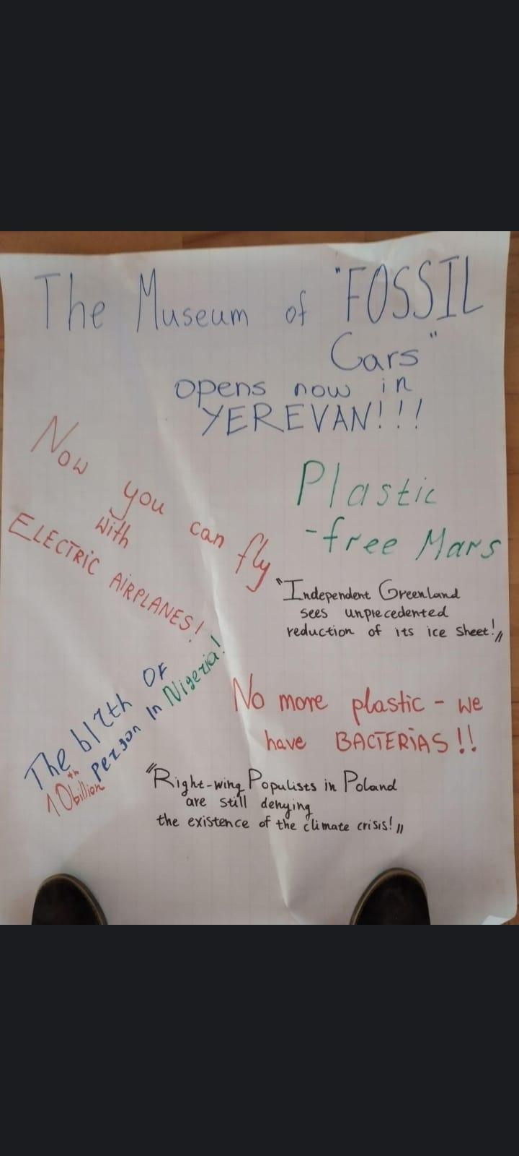
Newspaper Activity
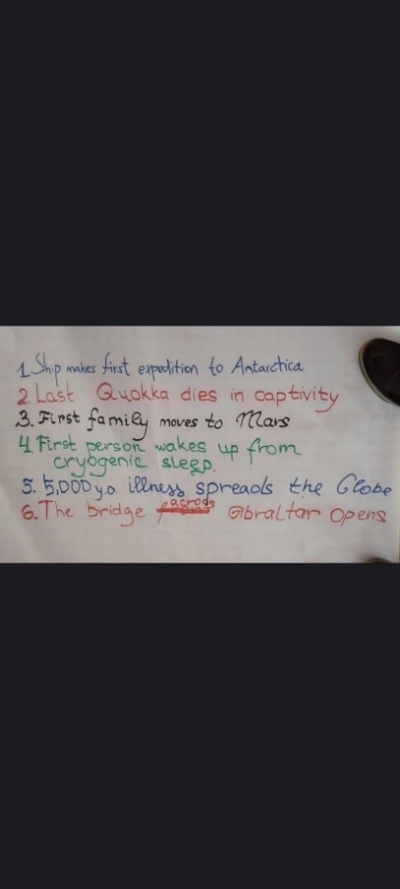
We started the day with a great breakfast. After the dancing game we did energizer we were really motivated. Then, we were separated into groups consisting of 4 people each. The main goal of this activity was the think about the future and come up with ideas related to the environment that can be a headline of a newspaper in 2050. So many creative ideas came from different groups. One of them was about energy sources, which is “%80 of the energy is coming from renewable energy sources”. Also, there were headlines about robots taking people’s jobs. After the headlines are read by facilitators, we were asked about how we felt after the newspaper activity and about the future.
Workshop with Matias at Park
After the newspaper activity, we gave a break to get ready and go to Frankfurt by bus and train. Frankfurt was an amazing city. We went to the park to meet Matias. He came to the park on his bike. Then, we made an inner circle for the ones who wanted to discuss the topics, and then people who are at the outer circle would change with the ones in the inner circle if they have anything to say about related topics. So, it was like a swap conversation. We talked about sustainable transportation. We talked about the vegan lifestyle. We have also discussed our individual impact of us on the climate crisis and what people can or can not do easily to maintain a sustainable lifestyle. We have also discussed the different lifestyles of people from different countries and how taking action for climate change differs for each citizen. Matias shared his own experiences about the climate crisis and what he does to contribute to the transportation systems in Frankfurt. His organisation, Klimaentscheid Frankfurt, is dedicated to combating climate crisis and making the city more livable. Its members believe that preserving and expanding urban greenery protects the climate and improves our health.
Garden
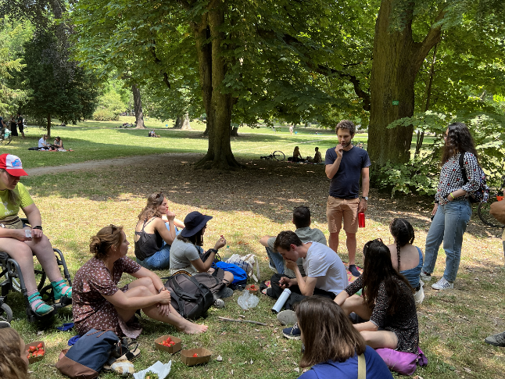
After the meeting with Matias, we went to the garden to meet Nikolaus. The garden is a solidary neighborhood around the green lung. The garden was beautiful. We met the representatives of Grüne Lünge, which is an initiative that is fighting for preserving Güntherburgspark and its unique ecology. The initiative is important because the city is planning to establish new builds around the park. Also, we have talked about the people who need living space and the ones who create this needed space. This creates a balance between the city center and ecology. The government doesn’t have to give this beautiful space for skyscrapers and high buildings which is amazing for environmental protection. The representatives of Gemuseheld*innen have told us about their mission, which is doing community gardening in the centre of the city. It is important for them to reconnect with their roots in the urban landscape and create a little garden with organic products. After the conversation with the people from the community, we went to a cafe in one of the gardens. Then, the group takes a little tour in the city.

DAY 7 - Sunday, June 18
Evaluation
On the last day of the project, we had different types of evaluation. First, we chose our peers and talked to each other about questions which were given by our trainers. After this we talked about it a little bit. The second part of the evaluation was self-evaluation. It was a really good part because we thought about our strengths and weaknesses, which were very important for everybody.
Lunch
Today lunch was really different from others, because we had the food which George showed us, how to prepare and how to eat, which I can say was a kind of introduction of tradition. Later our hosts invited us to have coffee, sausage and waffles which was really kind and pleasant from them.
Conclusion
On the second part of the day, we again continued evaluation, but in a different way. Cornelia and Lars created very interesting things to evaluate the project in general, to evaluate activities and trainers. Also giving pluses and minuses to the eight competences.
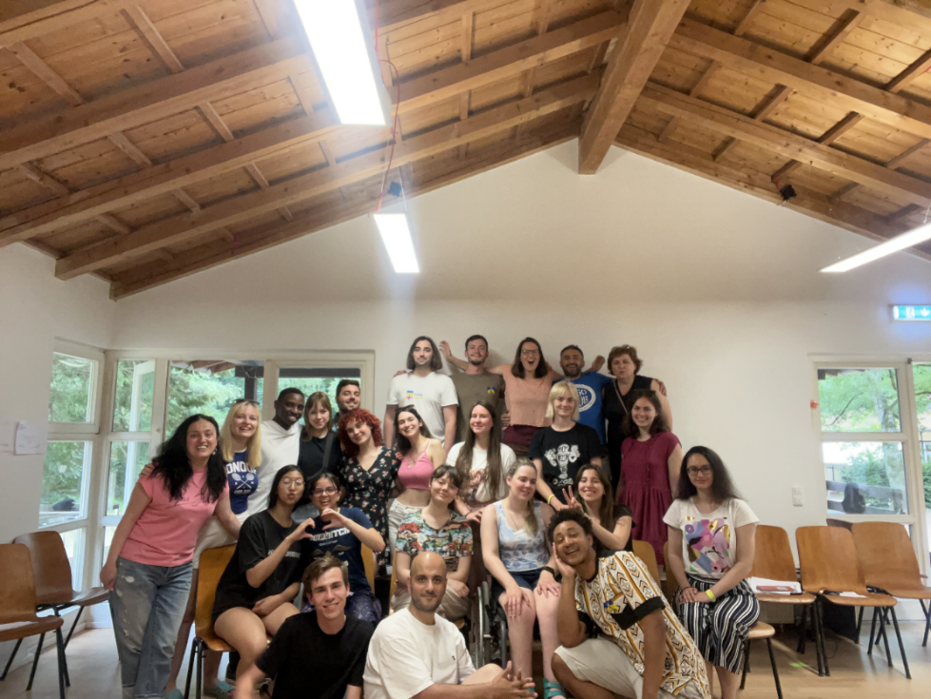
The most amazing and touching part was wishing all good feelings and emotions which we got during the project. We will take all good memories with us.

Participating Organisations
Turkey | PIYA Turkey | Website | contact.person(at)pigenclikdernegi.org
Estonia | ESTYES | Website | estyes(at)estyes.ee
Austria | Grenzenlos Österreich | Website | man.zhang(at)grenzenlos.or.at
Germany | ICJA | Website | youthexchange(at)icja.de
Greece | ELIX Youth Projects | Website | youth(at)elix.org.gr
Poland | SCI Poland | Website | longterm(at)poland.sci.ngo
Georgia | Civil Forum | Website | civilforumorg(at)gmail.com
France | CONCORDIA France | Website | vlt(at)concordia.fr
Armenia | Progress | Website | narekbotsinyan(at)gmail.com
Hungary | Egyesek | Website | tamas.mahner(at)egyesek.hu
Slovakia | Mladiinfo Slovensko | Website | projects(at)mladiinfo.sk
Ukraine | Stella | Website | info(at)ngo-stella.org
Czech Republic | INEX-SDA | Website | lenka.kaderabkova(at)inexsda.cz

Coordinating Organisation
ICJA Freiwilligenaustausch weltweit e.V.
Andreas Schwab
Nikolaus Ell
Stralauer Allee 20E
10245 Berlin
www.icja.de

This project is registered as local awareness-raising activity associated with the Raising Peace campaign
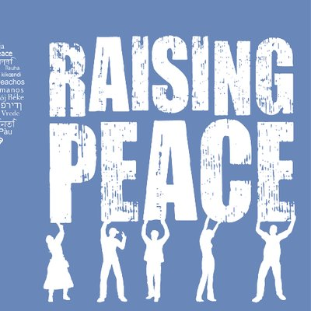
Raising Peace is a networking initiative that aims to contribute to the construction of peace, the guarantee of human rights all over the world, and to highlight the role that International Voluntary Service (IVS) plays in the field. The programme achieves this through advocating for human rights, non-formal education training and capacity building, empowerment of activists and organisations and through communication and visibility campaigns.
This project was co-funded by the Erasmus+ Programme of the European Union.


The European Commission support for the production of this publication does not constitute an endorsement of the contents which reflects the views only of the authors, and the Commission cannot be held responsible for any use which may be made of the information contained therein.

© 2023 - ICJA Freiwilligenaustausch weltweit e.V.

