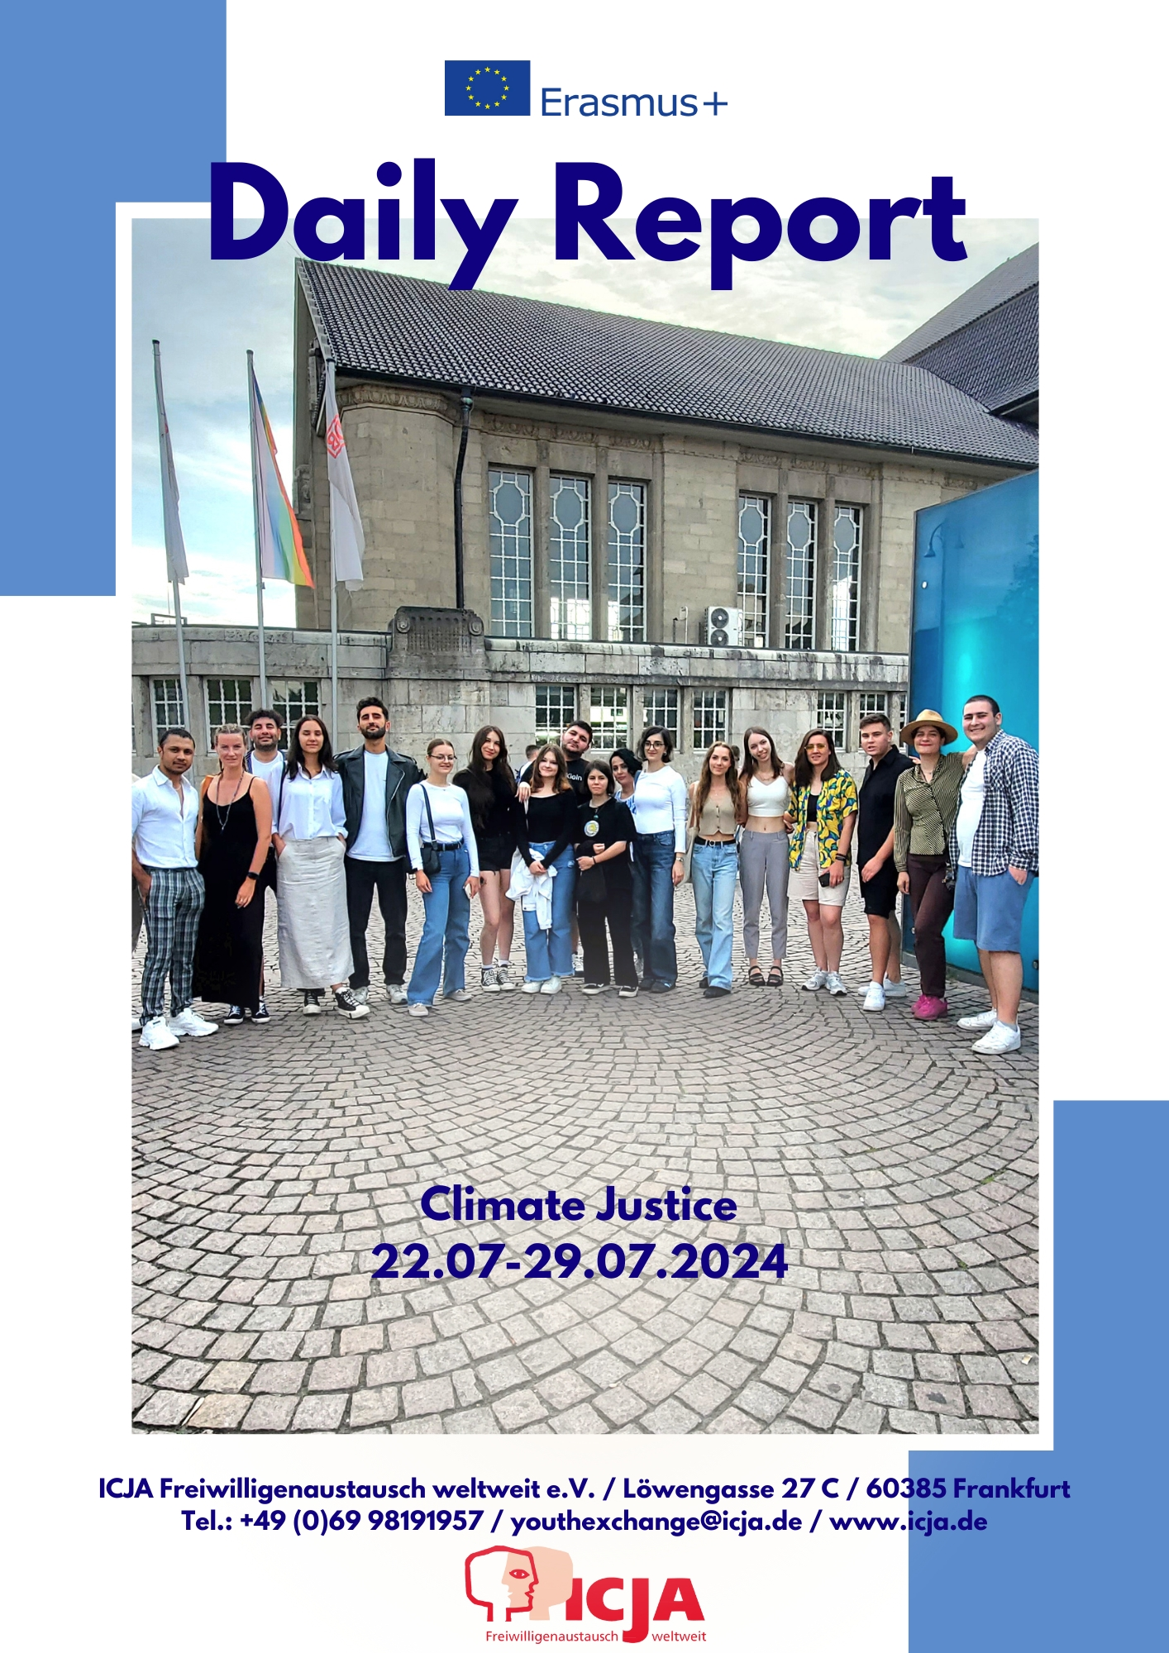

Esma Tari, ICJA e.V.

Background of the Initiative
Since 2015, ICJA offers trainings and youth exchanges in the frame of a concept we call “Young Activists for Peace”. Until now over 400 participants came from different corners of the European Union, Eastern Europe and Caucasus, as well as the Mediterranean Region
The “Young Activists for Peace” projects offers a wide range of activities, topics and pedagogical concepts in the field of peace education, trainings for democracy, empowerment of youngsters with fewer opportunities etc. We do this, because we believe in the impact of this work on the young participants who will contribute democratic and peaceful societies in the long term.
Global warming is a fundamental threat to all people on earth, but in different ways: The lifestyle of the rich is the main cause of the greenhouse effect; people in the global south suffer the most from the consequences, like drought, heat waves and floods. Especially poor and young people in the global North and South are bearing the consequences of a climate crisis they did not cause.
The focus of this training was the worldwide fight for climate justice. Together we looked for positive role models and helpful competences to achieve a more peaceful and sustainable future for all of us.
Goals of the Training
The training was held for young activists who wanted to get knowledge and skills and actively work for climate justice and peace. About 25 youth and young adults from Europe and neighbouring countries were invited to the training. The goals were:
- to get to know people, initiatives and their activities for climate justice;
- to gain an overview of the global problems caused by global warming and environmental pollution;
- to share experience and practice with other international participants and their youth organisation and jointly develop new methods and approaches in the field of sustainability and the UN sustainability goals;
The training consisted of the following modules:
- Workshops on understanding global warming e.g. "climatefresk”
- Workshops on just and sustainable nutrition e.g. "Food Justice".
- Workshops with examples from Global Learning;
- Visit to the Rainforest Centre "Centre for Global Sustainability"
- Workshops on creative events and campaigns on climate justice
- Learning from best practice: Excursions to initiatives in Darmstadt and Frankfurt that work for climate justice, e.g. Fridays for future, students for future.

Daily Reports
22.07.2024 (Arrival Day)

1. List of General Activities
- Starting with name games
- Creating project rules
- Introduction of coordinators and participants
- Dinner
- Detailed discussions about project process and distribution of documents
2. Detailed Description and Commentary of the Day
Starting with Name Games
We started the day with name games. This game allowed all participants to get to know each other. With everyone's participation, it created an interactive and fun environment. This activity set a warm atmosphere in the group and provided a good basis for the following activities.
Creating Project Rules
After that, we divided into different teams and created the project rules. This process allowed everyone to share their ideas and agree on common rules. These rules, made through group work, will help the project to proceed in a disciplined and orderly way.
Introduction of Coordinators and Participants
After the coordinators introduced themselves, we participants had the chance to introduce ourselves in more detail. In this part, we answered questions about where we live, our expectations from the project, and other questions that will make the project more comfortable for us in the coming days.
Dinner
We had a very delicious dinner. Dinner was a great opportunity for everyone to come together, relax from the day's tiredness, and have pleasant conversations. Thanks again for the dinner!
Detailed Discussions about Project Process and Distribution of Documents
After dinner, we came together again to talk more about the project process. We discussed details such as the necessary documents for reimbursements and the project's schedule. Each team was given project reports, and information was provided on how to fill out these reports.
3. Results, Conclusions, and Future Applications
- Results: Thanks to the activities carried out throughout the day, participants got to know each other, project rules were determined, and detailed information about the organization was obtained.
- Conclusions: A strong communication and cooperation environment was created within the group. Everyone's free sharing of ideas increased their contribution to the project.
- Future Applications: The experiences of this day will help us to work more organized and efficiently in the coming days. Also, the rules and information obtained today will allow us to run the project more regularly and planned.

23.07.2024 (First Day)

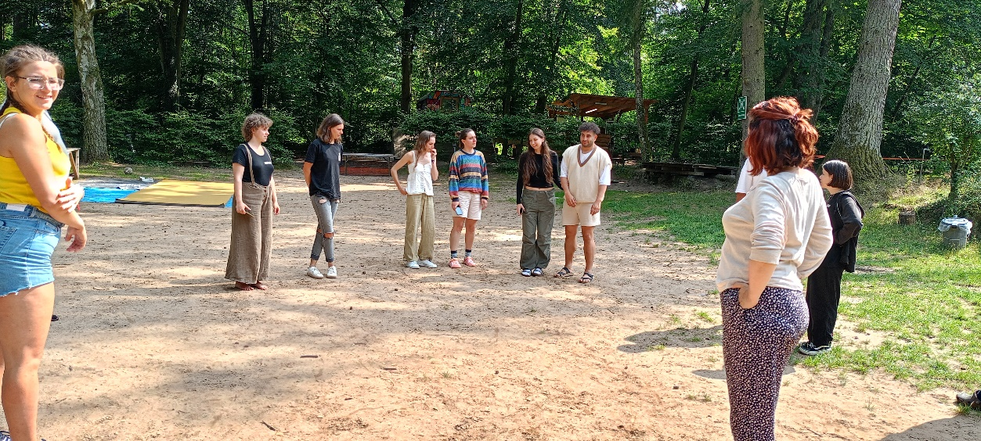
1. List of General Activities
- Daily Check-In with the team members;
- Two Truths and One lie game in the forest;
- Meditation Excersise
- Discussing three topics concerning food and finding solutions;
- Food Justice Training;
- Daydreaming Excersise
- Preparing dinner with chef
- YouthPass Presentation

2. Detailed Description and Commentary of the Day
Daily Check-In with the Team Members
Each morning, we gather for a daily check-in, fostering open communication among team members. This session allows us to share updates, address concerns, and set goals for the day. It’s a valuable time to ensure everyone is aligned and motivated, promoting teamwork and accountability.
Two Truths and One Lie Game in the Forest
In the serene setting of the forest, we played “Two Truths and One Lie.” This engaging game helped us learn fun and surprising facts about each other, enhancing our bond and encouraging a deeper understanding of our teammates in a relaxed, natural environment.
Meditation Exercise
Our meditation exercise provided a peaceful break from daily activities. We focused on breathing techniques and mindfulness, helping us center ourselves and reduce stress. This practice not only refreshed our minds but also improved our concentration and emotional well-being.
Discussing Three Topics Concerning Food and Finding Solutions
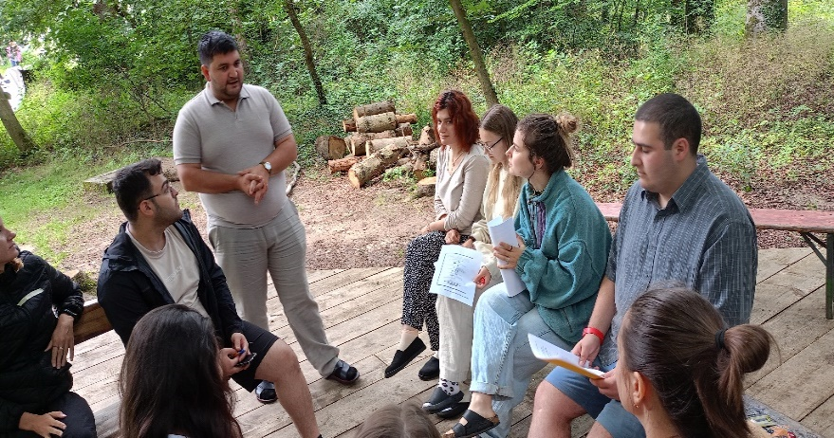
We delved into three pressing food-related issues, brainstorming innovative solutions. Through collaborative discussions, we explored sustainable practices, curing non-communable diseases, access to healthy food, and climate crisis. This session fostered critical thinking and problem-solving, aiming to make a positive impact on our community.
Food Justice Training
The food justice training was an eye-opener, highlighting the importance of equitable food distribution and access. We learned about the systemic barriers affecting marginalized communities and explored ways to advocate for fair policies. This training empowered us to contribute to a more just and sustainable food system.
Daydreaming Exercise
The daydreaming exercise allowed us to unleash our creativity and envision future possibilities. We spent time imagining new ideas and projects without constraints, which sparked innovative thoughts and inspired us to think outside the box. This activity highlighted the power of imagination in problem-solving. We drew everything we had imagined while daydreaming, so basically we drew our future how we imagined it.
Preparing Dinner with Chef
Working alongside a our delightful chef, we prepared a delicious dinner. This hands-on experience taught us valuable culinary skills and the importance of teamwork in the kitchen. It was a delightful way to bond over food, share responsibilities, and enjoy the fruits of our labor together.
YouthPass Presentation
In the YouthPass presentation, our trainer Celina took the lead, informing us about what YouthPass is and why it is beneficial. She explained how YouthPass serves as a recognition tool for non-formal learning in youth projects, highlighting its importance for personal and professional development. This session provided clarity on how YouthPass can enhance our future opportunities and validated the skills and experiences we will gain throughout the project.
3. Results, Conclusions, and Future Applications
Results
Today’s activities enhanced team cohesion, personal growth, and skill development through engaging exercises, practical tasks, and informative sessions, promoting effective communication, creativity, and continuous learning.
Conclusions
The blend of interactive games, practical tasks, and informative sessions highlighted the importance of teamwork, creativity, and consistent learning, significantly benefiting personal and collective development.
Future Applications
Regular check-ins, team-building exercises, meditation, and creative brainstorming sessions will enhance future projects, while food justice insights and culinary skills will inform our advocacy and collaborative efforts.

24.07.2024

MAIN ACTIVITIES OF THE DAY
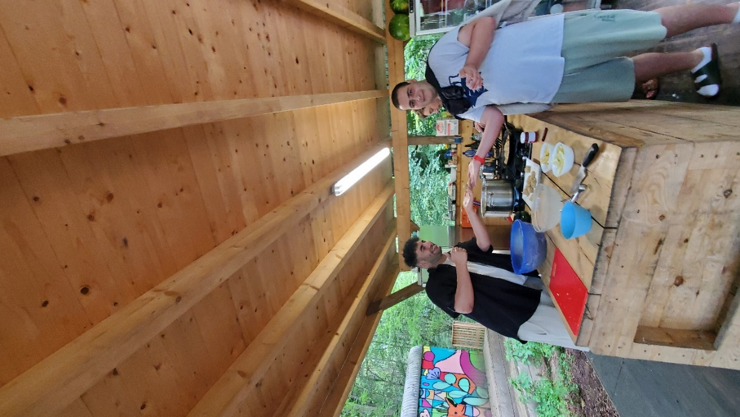
Simulation Game- “Convention within the framework of Planetary Healthy Diets”
DeRoling and Reflection
Outdoor group exercise “Feel”
Experiences in Climate Justice
Daily Reflection

Activity 1: Simulation Game on Food Justice

The third day of the project started with the daily check-in, the presentation of the agenda and main activities, and a check on participants' mood and readiness to start.
The day began in the main seminar room, where the trainer-facilitator introduced the session "Convention within the Framework of Planetary Healthy Diets," a simulation exercise. The trainer detailed the exercise and inquired if anyone had experience with simulation games.
The stated problems were healthy food, public health, and the economy, with the main actions occurring in two countries, Northland and Kaleido.
After a detailed introduction of the roles, participants divided into groups, and the simulation game began.
The groups were:
Northland government
Farmers association of Northland
Kaleido Government
Sustainable Food Alliance (SFA)
Kaleido National Farmers Association
Researchers
Global Organization- Doctors
Tasty Food – Mega Business
First, participants received role descriptions and discussed them within their groups. Following the role distribution, the players began the negotiation stage, which continued until lunch.
After lunch, participants resumed the simulation. The next stage was the roundtable facilitation. With Celina’s facilitation, government representatives, researchers, and civil society organizations from both countries began discussing the problem.
The simulation concluded with a roundtable summary and a press conference.
After the game, the de-rolling process started with an outdoor exercise designed to break the simulation roles and bring participants out of the game's mindset.
Following the outdoor exercise, the game facilitator initiated the simulation reflection, divided into three main parts:
Participants feelings.
The Reflection for the rolls.
Game general structure reflection.
After the reflection participants have free time and dinner.
After dinner, all the participants gathered to discuss their experiences in climate justice, sharing insights and personal stories. The conversation was lively, reflecting the diverse backgrounds and perspectives of those present. Some participants spoke about grassroots initiatives in their communities, while others highlighted policy changes at the national and international levels. The exchange of ideas and strategies was not only informative but also inspiring, fostering a sense of solidarity and collective purpose.

25.07.2024
Overview / List of Activities
- Watched a documentary on climate justice.
- Walked in the forest with Claus and learned about measuring tree heights and various markings.
- Traveled to Darmstadt by bus, explored the city, and enjoyed the evening.
Detailed Description and Commenting on the Day
Documentary on Climate Justice We began the day by watching an insightful documentary about climate justice. The film covered various aspects of climate change, its impacts on different communities, and the global efforts to mitigate these effects. It was a thought-provoking start that set the tone for the rest of the day.
Forest Walk and Nature Exploration After the documentary, we headed out for a walk in the forest guided by Claus. During our walk, Claus taught us how to measure the height of trees using simple tools and techniques. We also learned about different markings used in forestry and their significance. This hands-on experience was both educational and enjoyable, allowing us to connect with nature and understand its importance in the context of climate justice.
Evening in Darmstadt Post-dinner, we took a bus trip to Darmstadt. The city exploration was a delightful experience where we got to see various landmarks and enjoy the evening ambiance. It was a great way to wind down after an educational day, providing a balance of learning and leisure.
Conclusion / Outcomes and Application of those for the Future
The activities of the day provided a comprehensive understanding of climate justice from different perspectives. The documentary highlighted the importance of global cooperation in tackling climate change, while the forest walk emphasized practical knowledge and the significance of preserving nature. The evening trip to Darmstadt offered cultural insights and relaxation, showcasing the importance of balance in our efforts towards climate justice.
Moving forward, the knowledge gained today will be instrumental in our future projects and initiatives. Understanding the theoretical aspects through documentaries and applying practical skills in real-life scenarios can greatly enhance our contributions to climate justice.
26.07.2024/ Friday
- List of activities
- Daily check-in with team members
- Questions in terms of climate justice on the scale from 0 to 10
- Two blocks of KoalaCollective presentations
- Daily Reflection
- Movie night and cultural evening
- Detailed Description and Commenting on the Day
KoalaKollectiv: Today we became acquainted with a new organization, initially founded in Frankfurt, which fights for climate justice. Before elaborating more on this topic, we started off by answering a range of questions. For example: Has climate affected the prices of the products and our possibility to buy them? Some of the participants shared their experiences.
Our introduction to KoalaKollectiv began with a short check-in as to what we are grateful for. A range of key-points connected to climate crisis were covered. For example, we found out that it was the process of colonialism that contributed to the crisis we deal with today. In short, industrialized countries of the Global North are historical perpetrators of climate change and people of the Global South have been dealing with its consequences all along. “The richer, the greater the consumption of nature” as they say.
Next, we discussed what are our natural emotional responses to climate crisis and we agreed that anxiety grief, sadness, fear and despair here are okay. What we should do is release those feelings in order to mitigate them.
Finally, we observed miscellaneous roles in the ongoing battle against climate crisis, such as an acuptunist, broker, pioneer, gardener, questioner etc. Using the model of ikidai each of us had the opportunity to ponder our own role by answering three questions.
Daily reflection was based on a Climate Action Canvas which allowed us to reflect on our own achievements, personal strengths and potentials and how they can be implemented in our fight against climate change.
Movie night and cultural evening: in the end of the day we gathered together to watch a movie “Dear Future Children” and shared foods and drinks from our countries.
- Conclusion / Outcomes and Application of those for the Future
The activities of the day provided us with a short overview of the functioning of KoalaCollectiv. We dived more into the reasons behind climate crisis, possible ways of mitigating it and dealing with anxiety along the way. The movie gave us a picture of horrifying consequences of war, climate change and oppressed activism in order to inspire us and our future children to prevent this from.

Date: 27/07/2024 Saturday
Our day began with our usual morning routine, which included breakfast and a circle with games. This allowed everyone to start the day energized and engaged. Following this, we travelled to Frankfurt to visit the "Vegetable Heroes" project, a community initiative dedicated to sustainable agriculture and urban gardening.
Upon arrival, participants were introduced to the concept of the project, which focuses on growing a variety of edible plants within urban settings. The organizers provided an informative presentation about the origins of the initiative, its mission, and the various techniques they employ to cultivate their gardens.
During the tour, participants had the opportunity to taste some of the freshly harvested produce, which highlighted the quality and freshness of the plants grown by the "Vegetable Heroes." This hands-on experience was both educational and enjoyable, offering insights into sustainable living and the importance of locally grown food.
After the tour and tasting, participants had free time to explore Frankfurt on their own. This provided an excellent opportunity to experience the city's vibrant culture, historical landmarks, and local cuisine. Some chose to visit nearby attractions, while others relaxed in one of the city's many parks or cafes.
We then reconvened and returned to the forest, where we had dinner. The meal was a perfect end to the day, featuring a selection of nutritious and delicious dishes that aligned with the day's theme of healthy living. After dinner, we gathered for our customary evening discussion, where everyone shared their thoughts and reflections on the day's activities. This discussion fostered a sense of community and allowed participants to exchange ideas and experiences, further enriching the day's learning

28.07.2024/ Sunday
- List of activities
- Daily check-in with team members
- Questions in terms of climate justice on the scale from 0 to 10
- Movie kiss the ground
- Yout pass competences
- Daily Reflection
- Fun
- Detailed Description and Commenting on the Day
Kiss the ground: Today’s activities commenced with breakfast, setting a positive tone for the day. Following the meal, we arranged the tables and chairs to create a cozy viewing area for our movie session. We had the option to either watch a film or visit a forest to engage in outdoor games. After careful consideration, we opted for the film viewing as it promised to be more educational.
This film provided valuable insights into sustainable agriculture, focusing on soil health, plant growth, and the impact of farming practices on CO2 levels. It offered a comprehensive overview of how improving soil management can contribute to a healthier planet. The documentary highlighted the crucial role of farmers in this process and presented actionable steps for enhancing soil quality and mitigating climate change.
Overall, the movie proved to be an enlightening experience, offering us a deeper understanding of environmental issues and potential solutions. It has made us more conscious of our environmental impact, and we were appreciative of the opportunity to watch and learn from this impactful film.
Daily reflection like always we were discussing our group feelings and new knowledge. We were also talking about how we can improve our behave in different situations.
Conclusions
The day concluded on a high note as we reflected on our experiences and the bonds we had formed. We were impressed with the success of our project and the friendships that developed throughout our time together. As it was our last night at the camp, we celebrated with a barbecue prepared by our cook, George. We enjoyed a delightful evening filled with games and laughter. The team that guided us through this experience was exceptional, and the positive energy was palpable, with smiles all around.

Participating Organisations
Armenia | Progress | programs.pyngo(at)gmail.com | Armenia
Belgium | CODEC | codec.ka1(at)gmail.com | Belgium
Estonia | ESTYES | estyes(at)estyes.ee | Estonia
Finland | Maailmanvaihto | maailmanvaihto(at)maailmanvaihto.fi | Finland
Romania | Geyc | office(at)geyc.ro | Romania
France | Solidarites Jeunesses | sle(at)solidaritesjeunesses.org | France
Georgia | Civil Forum | civilforumorg(at)gmail.com | Georgia
Germany | ICJA | youthexchange(at)icja.de | Germany
Serbia | Young Researchers of Serbia | vss(at)mis.org.rs | Serbia
Spain | De Amicitia | info(at)deamicitia.org | Spain
Turkey | PIYA | contact.person(at)pigenclikdernegi.org | Turkey
Ukraine | STELLA | info(at)ngo-stella.org | Ukraine

Visibility
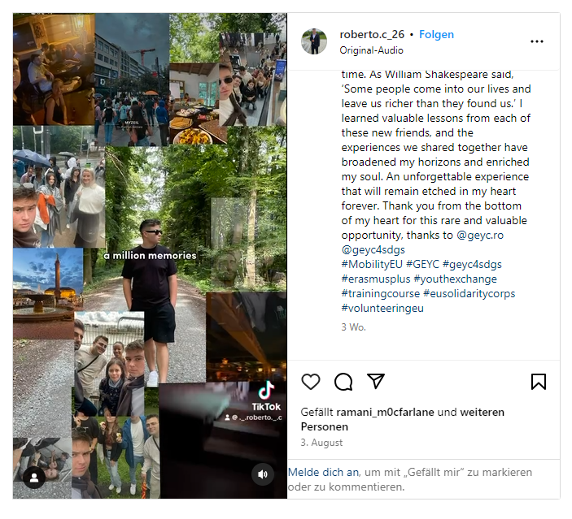

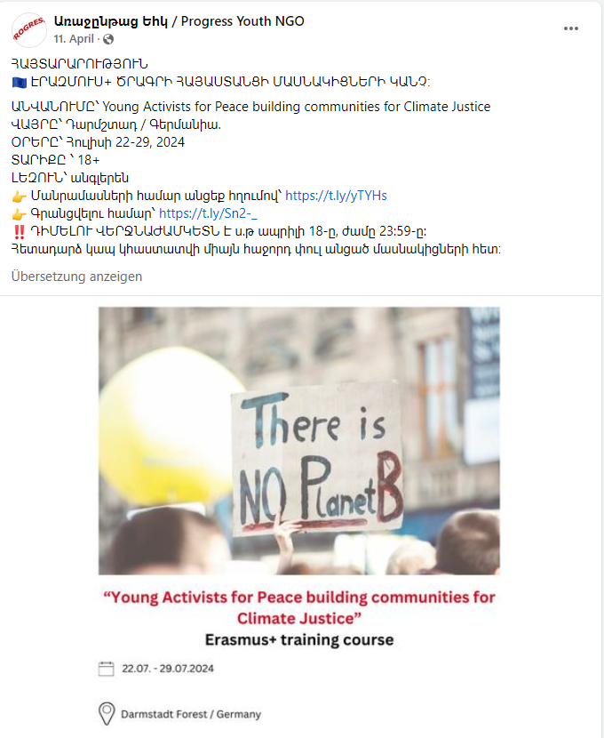

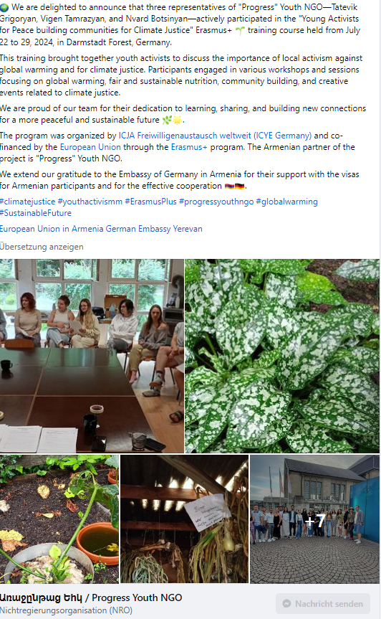

Coordinating Organisation
ICJA Freiwilligenaustausch weltweit e.V.
Andreas Schwab & Nikolaus Ell Stralauer Allee 20E 10245 Berlin www.icja.de

This project was co-funded by the Erasmus+ Programme of the European Union.


The European Commission support for the production of this publication does not constitute an endorsement of the contents which reflects the views only of the authors, and the Commission cannot be held responsible for any use which may be made of the information contained therein.

© 2024 - ICJA Freiwilligenaustausch weltweit e.V.

